EENG 385 - Electronic Devices and Circuits

BJT Curve Tracer: Intro to MultiSim and the 555 Timer

Lab Document

# Outcomes and Objective

The outcome of this lab is to analyze, simulate and assemble a circuit that generates a periodic square wave using a 555 Timer and compare the expected behavior of the circuit from each mode of analysis. Through this process you will achieve the following learning outcomes:

* Use a software tool to perform time and frequency domain analysis of an electronic circuit.
* Assemble a circuit on a PCB using the equipment in the laboratory.
* Use laboratory test and measurement equipment to analyze electronic circuits.

# Analysis: 555 Timer

We will start by examining the behavior of today’s circuit and then use our understanding of the circuit to quantify the behavior of the circuit. The circuit shown Figure 1 is built around the 555 Timer, a chip seen since the early 1970s. Its use is now limited to niche applications; it is not something you are likely to use much in industry. That said, an analysis of the circuit Figure 1 will allow us to practice valuable skills.

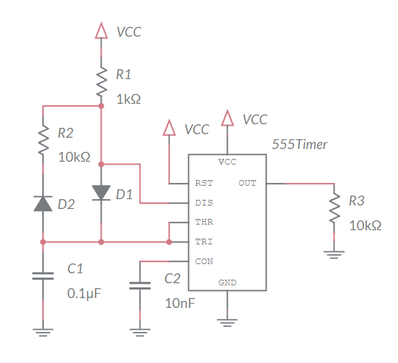

Figure 1: The output of the 555 Timer oscillates with a predictable period and duty cycle.

In order to analyze the circuit in Figure 1, you first need to understand the internal operation of the 555 Timer chip. A highly simplified view of its internal structure is shown in Figure 2. You will notice some of the pins shown in Figure 1 are not shown in Figure 2. These omitted pins do not affect the behavior of the circuit shown in Figure 1, so to simplify the explanation, they are omitted. Finally, note that VCC is the system voltage in Figure 1, for simplicity, we will assume throughout the lab that VCC = 9V.

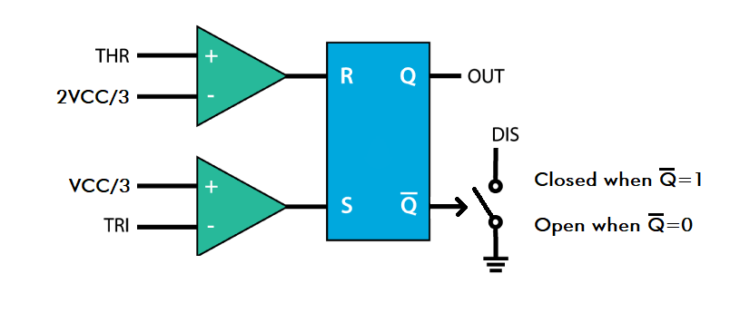

Figure 2: A highly simplified rendering of a 555 Timer’s internals.

Let’s start our exploration of Figure 2 by examining the pair of green triangles called comparators. We will call the upper comparator the “R-comparator” because it is connected to the R input of the blue box. Likewise, we will call the lower comparator the “S-comparator”. Notice each comparator has a + and – input on its left, and its output on the right. The behavior of a comparator is described by the following two statements.

* When the voltage on the + input is larger than the voltage on the – input, the output of the comparator equals VCC.
* When the voltage on the - input is larger than the voltage on the + input, the output of the comparator equals GND.

Use these definitions and the schematic in Figure 2 to answer the following two questions. Assume that VCC = 9V, so state your answers in terms of numerical volts, not symbolically in terms of VCC.

1. For what range of voltages on THR does the R-comparator output VCC?

**In order to output VCC THR needs to be larger than 2VCC/3 which equals 6V.**

1. For what range of voltages on TRI does the S-comparator output VCC?

**In order to output VCC TRI needs to be less than VCC/3 which equals 3V.**

Notice the THR and TRI inputs to the 555 Timer are tied together in Figure 1. We will call this common voltage *Vt* in the following text. Make note of this assignment now. Next, let’s look at the blue box in the middle of Figure 2 known as an SR-latch. The input voltages to the SR-latch come from the comparator. When the comparator outputs VCC, the SR-latch interprets this as a logic 1. A comparator output of GND is interpreted by the SR-latch as logic 0.

Table 1: State table for an SR-latch

|  |  |  |  |  |
| --- | --- | --- | --- | --- |
| S | R | Q |  | Name |
| 0 | 0 | Q |  | Hold |
| 0 | 1 | 0 | 1 | Reset |
| 1 | 0 | 1 | 0 | Set |
| 1 | 1 | X | X | Forbidden |

The last element of Figure 2 is the voltage-controlled switch connected to the output of the SR-latch. This switch opens and closes under the control of the signal, hence the arrow head. When the switch is closed, connecting the DIS pin to ground. When the switch is open, leaving the DIS pin “floating”, not connected to any voltage. In reality, this voltage-controlled switch is an NPN bipolar junction field effect transistor. However, since we have not studied them, I have replaced it with something more intuitive.

1. Now, let’s summarize our understanding of the components in Figure 2 to complete Figure 3. In this figure, the vertical axis represents the voltage of *Vt* (the common voltage of the TRI and THR pins in Figure 1). The voltage range of *Vt* is split into 3 ranges, 9V-6V, 6V-3V, and 3V-0V. For each of these ranges:
   * Describe the logic values on the S and R inputs of the SR-latch. (You already did this in a previous question.) Write 0 or 1 as the value of S and R.
   * Use the S, R logic levels to determine the Q output. Write 0, 1, or Q as the value of Q.
   * Use the Q output to determine the state of the switch. The value of the switch should be “open”, “closed,” or “hold”. Use “hold” when SR-latch is holding its output.
   * Use the switch value to determine the state of the DIS signal. The value of the DIS should be “open”, “GND,” or “hold”. Use “hold” when the Switch is holding its output.

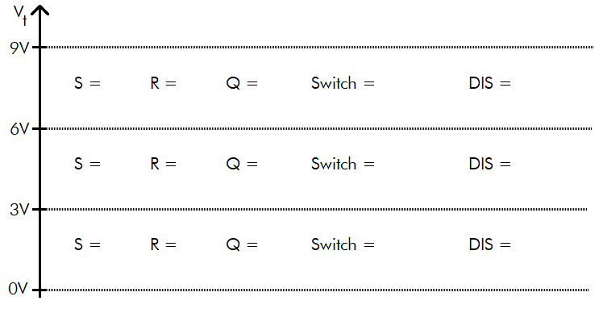

Figure 3: Determine the effect of Vt on the SR latch. Assume that VCC = 9V.

With our new understanding of the 555 Timer, let’s return to the circuit shown in Figure 1 so that we can understand the role of the external components in the operation of the circuit. We will approach this question by replacing the 555 Timer with the *Vt* and DIS signals examined in Figure 3. The resulting circuit, shown in Figure 4, contains resistors, capacitors, a 555 Timer, and D1, D2, diodes. We will study diodes in much more detail later, but for now, consider them as circuit elements allowing current to flow in one direction as indicated by the triangle. So, for example, D1 will only allow current to flow downwards and D2 will only allow current to flow upwards.

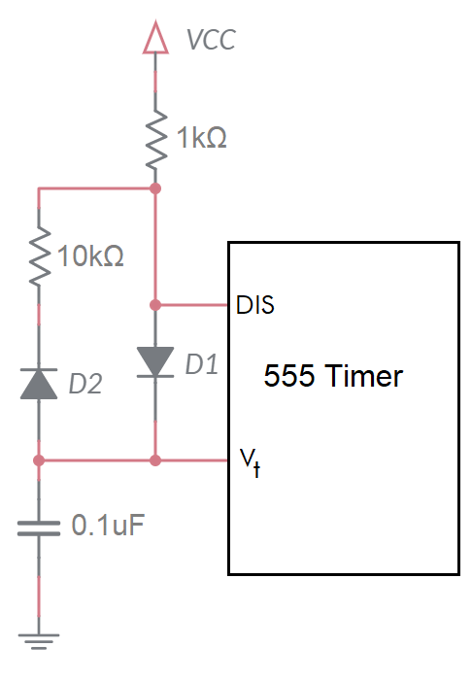

Figure 4: The circuit in Figure 1 with the 555 Timer replaced with the two signals examined in Figure 3.

Now, you will use the information from Figure 3 to determine to describe what the external circuit in Figure 4 functions like as *Vt* changes. Complete the sentence or write an expression for each of the bulleted items in questions 4 and 5. When two **bold** choices are separated by a “/”, replace them with the correct answer. Fill in underlines with values.

1. Determine the circuit behavior in Figure 4 when *Vt* is between 0V-3V.

* If *Vt*is between 0V-3V, then DIS is **open/closed** (Q=1).
* If DIS is **open/closed,** then current wants to flow from VCC through D1 to ground.
* This current flow will **charge/discharge** the capacitor with time constant RC = _______.
* The equation describing the **charging/discharging** capacitor is . Fill in the denominator of the exponent.
* Determine the time required for the capacitor to **charge** from 3V to 6V.
  + Set the *Vt(t)* equation equal to 3V and solve for *t*. This result is the time to charge from 0V to 3V. Represent your answer in microseconds and round to the nearest integer.
  + Set the *Vt(t)* equation equal to 6V and solve for t. This result is the time to charge from 0V to 6V. Represent your answer in microseconds and round to the nearest integer.
  + To get the time to **charge/discharge** from 3V to 6V, subtract the time to get to 3V from the time to get to 6V. This is 52s – 19s = 33s.

1. Determine the circuit behavior in Figure 4 when *Vt* is between 6V-9V.

* If *Vt* is between 6V-9V, then DIS is **open**/**closed**, (Q=0).
* If DIS is **open/closed,** then charge on the capacitor wants to flow through D2 to the grounded DIS.
* This current flow will **charge/discharge** the capacitor with time constant RC = _________.
* The equation describing the **charging/discharging** capacitor is Fill in the denominator of the exponent.
* Determine the time required for the capacitor to **charge/discharge** from 6V to 3V.
  + Set the *Vt(t)* equation equal to 6V and solve for *t*. This result is the time to discharge from 9V to 6V. Represent your answer in microseconds and round to the nearest integer.
  + Set the *Vt(t)* equation equal to 3V and solve for *t*. This result is the time to discharge from 9V to 3V. Represent your answer in microseconds and round to the nearest integer.
  + To get the time to **discharge** from 6V to 3V, subtract the time to get to 6V from the time to get to 3V. This is 363us – 134us = 229s.

Let’s now put all the pieces together to see how the external components and the internal structure of the 555 Timer, together, produce a periodic waveform. To do this, we will use Figure 5.

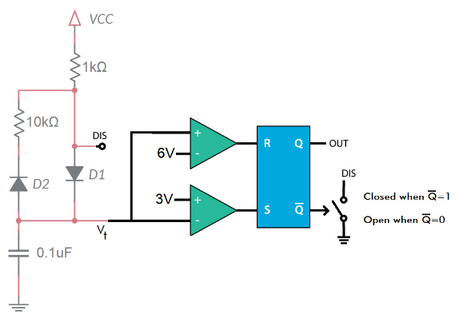

Figure 5: External circuits and internal organization of the 555 Timer .

You will examine the behavior of the system in terms of *Vt.* Complete the following set of statements using Figure 5 and the answers you provided to previous questions. When two answers are separated by a “/”, circle the correct answer. Fill in underlines with values.

1. Assume Vt is less than 3V.
   1. Then S =____ 1 and R =____ 0.
   2. Then Q = 1 and .
   3. Then DIS is **open/closed.**
   4. Then the capacitor is **charging/discharging.**
   5. Then it takes 33____us to **charge** the capacitor from 3V to 6V.

So, whenever *Vt* drops below 3V, the capacitor starts charging, increasing *Vt*.

1. Assume *Vt* is greater than 6V.
   1. Then S =____ 0 and R =____ 1.
   2. Then Q = 0 and .
   3. Then DIS is **open/closed.**
   4. Then the capacitor is **charging/discharging.**
   5. Then it takes 229____s to **discharge** the capacitor from 6V to 3V.

So, whenever *Vt* rises above 6V, the capacitor starts discharging, decreasing *Vt*.

1. Assume *Vt* is between 3V and 6V. The answers are given to you so that you can better follow what the circuit does.
   1. Then S = 0 and R = 0.
   2. Then Q and are unchanged.
   3. Then DIS remains unchanged.
   4. Then the capacitor charging state remains unchanged until *Vt* goes below 3V or above 6V

So, whenever *Vt* is between 3V and 6V, the capacitor continues behaving as it was before *Vt* entered the range 3V to 6V.

Note, *Vt* continuously oscillates between charging and discharging. As soon as *Vt* increases above 6V, the SR-latch changes state causing *Vt* to decrease. As soon as *Vt* drops below 3V, the SR-latch changes state causing *Vt* to start increasing. The cycle continues indefinitely.

1. Plot *Vt* vs. *time*. To help you, I have plotted voltage vs. time for *Vt* for the charging and discharging states. You can cut-and-paste the relevant pieces of the curves from Figure 6 to form your answer. Draw as many charge/discharge cycles as will fit.

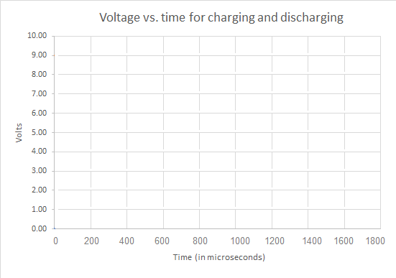

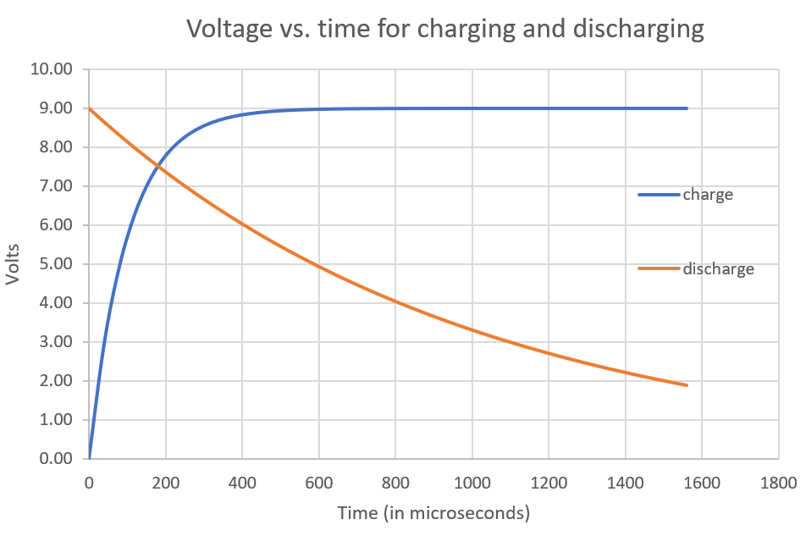

Figure 6: (Left) Voltage vs. time for Vt in both the charging and discharging configurations. (Right) Plot the charge/discharge curve of the capacitor using the information in the left graph.

1. Use this information to determine the rise time, fall time, and period of the waveform. Note the rise time corresponds to the output of the 555 Timer being high. The fall time corresponds to the output of the 555 Timer being 0V.

**The rise time is 33 µs, fall time is 239 µs and period of 239s + 33s = 272s**

1. Use the period to determine the frequency of the waveform.

**1/272s = 3.68 kHz**

1. The duty cycle of a waveform is the percentage of time when it is at a high voltage level. What is the duty cycle of the OUT pin?

**Duty cycle is 100*(33 µs/272s) = 12%.**

# Simulation: 555 Timer

Use the skills learned in Lab 0 to build the 555 Timer circuit analyzed in the previous section to build the circuit shown in Figure 7 in MultiSim Live.

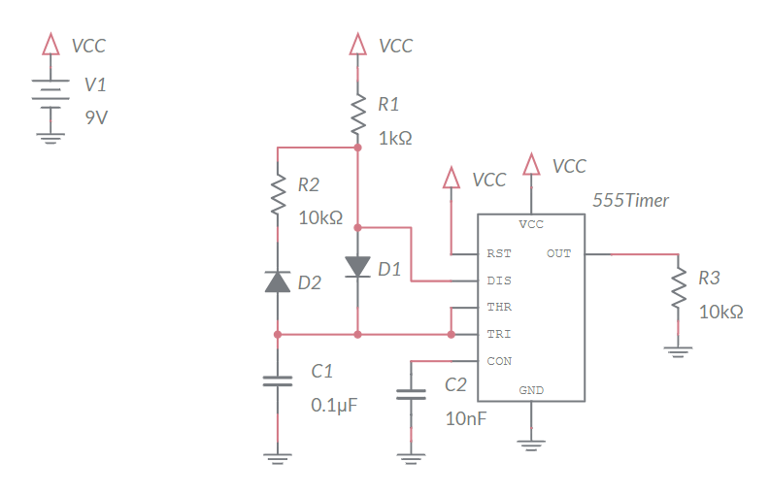

Figure 7: 555 Timer circuit to construct in MultiSim Live.

You will find the components to build the MultiSim Live simulation using the information listed in the table below.

* Make sure to give the resistors and capacitors the correct values.
* Make sure to include the probes on the TRI and OUT pins.

|  |  |  |
| --- | --- | --- |
| **Component** | **Tool Category** | **Name** |
| DC Voltage Supply | Sources | DC Voltage |
| Ground | Schematic connectors | Ground |
| VCC | Schematic connectors | Connector |
| Resistor | Passive | Resistor |
| Capacitor | Passive | Capacitor |
| Diode | Diodes | Diode |
| 555 Timer | Analog | 555 Timer |

Save your file by clicking on the 3x3 grid of squares in the upper left corner and select “Save”.

1. Export an image of your schematic using the export option in the main menu to output a PNG file of the schematic.
2. Simulate your circuit for 5 ms. Export an image of your timing diagram using the export option in the main menu to output a PNG file of the schematic. Note, the duration of the time high and low of the output signal will be different from your analysis.
3. Use the timing diagram to measure the time high, time low, period, frequency, and duty cycle of the waveform on the OUT pin. You may find the Cursor function in the Item tab to come in handy. You should find these values very close to those in the analysis.Time high =39 sTime low = 275sPeriod = 314s

Frequency = 3.18 kHz

Duty cycle = 12.4%

1. Use the timing diagram to measure the high and low voltages of the TRI pin. You may find the Cursor function in the Item tab to come in handy.

**High = 6.0V Low = 3.0V**

# Empirical: 555 Timer

This week, you will be soldering in the components associated with the POWER INPUT, 555 TIMER subsystems shown in the Figure 8schematic. It is important you do not solder in any of the other components in any of the other subsystems. This lab document contains cursory coverage of the assembly process. You can find much more detail in the Assembly Guide posted on Canvas.

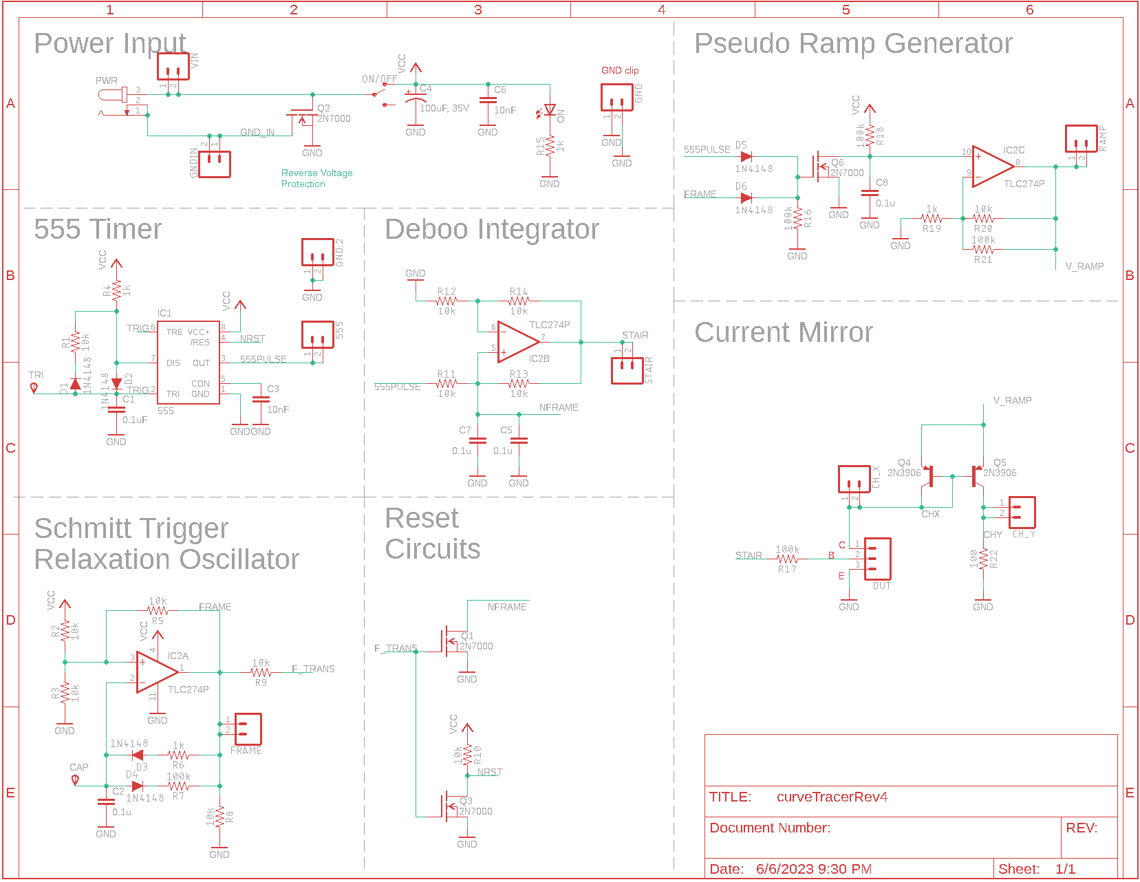

Figure 8: The schematic for the BJT curve tracer.

## POWER INPUT Subsystem

The POWER INPUT area of the schematic in Figure 8enables you to supply power to the BJT curve tracer board from either an power jack or through the VIN and GND terminals. A SPDT slide switch allows the user to turn the BJT curve tracer on or off while leaving the power input connected. An indicator LED confirms the BJT curve tracer is powered on when it is illuminated. A pair of capacitors smooths out the power delivered to the BJT curve tracer. Finally, a MOSFET disconnects the power input if you accidently reverse the positive and negative power leads. You will learn more about this MOSFET in a later lab.

## 555 TIMER Subsystem

The 555 TIMER subsystem in Figure 8 is identical to the circuit analyzed in in Figure 4.

## Parts Designators

Most of the parts in this schematic have a designator and a value. The designator is a letter followed by a number. The designator letter tells you what type of part it is, “R” for resistor, “C” for capacitor, etc. The designators on the PCB match those on the schematic in Figure 8. This provides you with a means to find a part. You should take a moment to notice parts which are logically related in the schematic are physically proximal on the PCB.

## Polarized Parts

Most of the parts you will solder into the PCB can be installed in more than one way. Parts which must be installed in a correct orientation are called polarized. If you would like to more information about the polarized parts you will install in your board, please check the Assembly Guide.

## Test Points

Test points are electrical connections to important points in the circuit and frequently are the target of test and measurement equipment. All the test points on the BJT curve tracer PCB are formed with pairs of pads that you will connect together with an approximately 1 cm long piece of wire – you can use the cut off end of resistor lead for this. These wire loops make it easy to connect oscilloscope probes and alligator clips to your to your circuit. Consult the Assembly Guide for a complete list of test point connections that you should solder this week.

## Part Identification

The BJT Curve Tracer has many loose thru-hole resistors of different values. It is worth your time to become familiar on how to interpret the resistors’ color bands. We will use the handy table in Figure 9 as our guide.

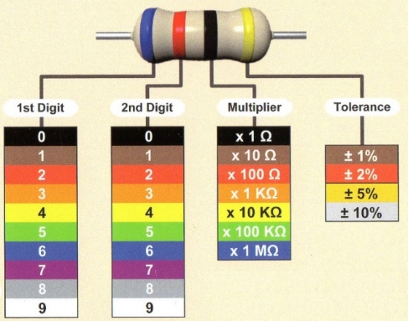

Figure 9: The colored bands on resistors indicate their resistance value.

The resistors provided with the curve tracer have 4 colored bands. When looking at a resistor, hold it so that the metallic gold band is to the right – all our resistors have 5% tolerance. With the resistor correctly positioned, read the color bands from left to right, converting the colors into the numerical codes given in Figure 9. For example, let’s say that from left to right the color bands are red, red, orange, gold. This pattern converts to 22x1kΩ ±5% The first three bands are the resistance, in this case 22 kΩ. The fourth band is the range of resistances you can expect the resistor to have. This phrase means the actual resistance of the example resistor could be as low as 22 kΩ – 0.05*22 kΩ = 22 kΩ – 1.1 kΩ = 20.9 kΩ or as high as 23.1 kΩ. Check your understanding by filling in the blank space in Table 2 with the correct color or resistance code.

Table 2: Complete the missing entries in the table of resistance color codes.

|  |  |  |  |  |
| --- | --- | --- | --- | --- |
| Value | Band 1 | Band 2 | Band 3 | Band 4 |
| 220 |  |  |  |  |
| 2.2k |  |  |  |  |
| 3.3k |  |  |  | Gold |
| 4.7k |  | Purple |  |  |
| 6.8k |  |  |  |  |
| 10k |  |  |  |  |
| 15k | Brown |  |  |  |
| 33k |  |  |  |  |
| 47k |  |  | Orange |  |
| 100k |  |  |  |  |
| 470k |  |  |  |  |

To make sure you can positively identify all the elements in the schematic complete Table 3 by filling in the **Match** column with the letter corresponding to the **Schematic Symbol** for a **Physical Part**.

Table 3: Match the schematic symbol with the corresponding part.

|  |  |  |  |
| --- | --- | --- | --- |
| **Schematic Symbol** |  | **Match** | **Physical Part** |
| A |  | D | WCAP-ATG8 |
| B |  | F | 151051VS04000 |
| C |  | E | Goldmax 32 Series |
| D |  | A | PJ-202A |
| E |  | I | TC254P |
| F |  | B |  |
| G |  | J |  |
| H |  | G | DO-35 |
| I |  | H | CF 4-7k |
| J |  | C | EG1218 |

## Testing

You should take care and align the resistors so their gold tolerance bands all facing the bottom of the board. This positioning will make it easier to read their values and compare your work to pictures of the assembled board. Look at the **How To: Solder** posted on Canvas for recommendation on how to solder through hole parts.

Once you have completed assembly of your POWER and 555 TIMER subsystems, perform the following test.

1. Power up an oscilloscope, attach a probe to Channel 1 and configure it as follows.

|  |  |
| --- | --- |
| Ch 1 probe | 555PULSE testpoint |
| Ch 1 ground clip | BJT ground loop |
| Horizontal (scale) | 200 µs |
| Ch 1 (scale) | 1V or 2V (whatever fits better) |
| Ch 2 probe | TRI pin of 555 Timer |
| Ch 2 (scale) | 2V |
| Trigger mode | Auto |
| Trigger source | Ch 1 |
| Trigger slope | ↑ |
| Trigger level | 4.5V |

1. Set the GND reference of Ch 1 and Ch 2 to the lowest visible reticule. The waveforms will overlap the same as they did in the MultiSim simulation. The TRI pin of the 555 Timer is available by remove the end of the oscilloscope probe and putting the tip into the yellow circled pad in Figure 10. Note that this pad is labeled “TRI”.

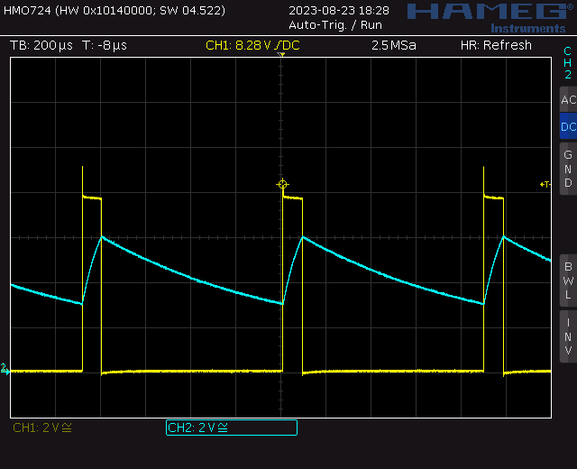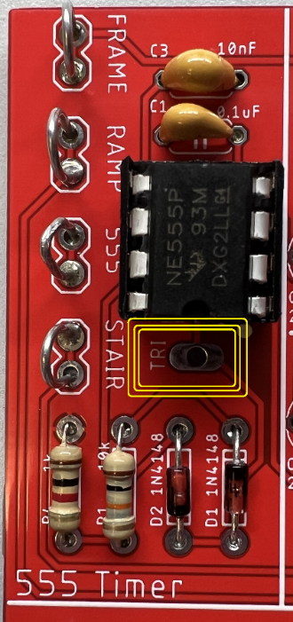

Figure 10: (Left) The TRI pin of the 555 Timer is available at the circled pad. (Right) An oscilloscope trace showing the two output you need to capture. Note that this image was captured on a Rhode&Schwarz HMO724.

1. Take a screen shot of the two waveforms and include in your lab report. Screen shot the oscilloscope traces on USB. Cell phone pictures will lose points.  
   [Save] → Save → Format → 24-bit Bit... (*.bmp) [Save] → Save → Press to Save

# Comparison: 555 Timer

Complete the **Analysis, Simulation** and **Empirical** columns of the following table using the information you found throughout this lab. Represent your answer to 3 significant figures using the units given in parenthesis in the **Quantity** column. You will need this table in later labs, so keep it handy.

Table 4: Comparison of the timer output from analysis, simulation and the actual circuit.

|  |  |  |  |
| --- | --- | --- | --- |
| **Quantity** | **Analysis** | **Simulation** | **Empirical** |
| Time high (µs) | 33.0 µs | 39.0 µs | 38us µs |
| Time low (µs) | 239 µs | 275 µs | 260 µs |
| Period (µs) | 660 µs | 314 µs | 295 µs |
| Frequency (kHz) | 3.68 kHz | 3.18 kHz | 3.37 kHz |
| Duty Cycle | 12.0% | 8.70% | 12.8% |

# Turn In: 555 Timer

1. Make a record of your response to numbered items below and turn in a single lab report for your team on Canvas using the instructions posted there.
2. Include the names of both team members at the top of your solutions.
3. Use complete English sentences to introduce what each of the items listed below is and how it was derived.

Hint, use Ctrl+click to follow links. This also works for all the Figures and Tables in these labs.

**Analysis** Question 1, 2 Voltage to assert S and R

**Analysis** Question 3 SR Latch truth table

**Analysis** Question 4 *Vt*vs. TRI state

**Analysis** Question 5 Time to charge 3V to 6V

**Analysis** Question 6 Time to discharge 6V to 3V

**Analysis** Question 7 Behavior when *Vt*is less than 3V

**Analysis** Question 8 Behavior when *Vt* is greater than 6V

**Analysis** Question 9 Plot *Vt* vs. *time*

**Analysis** Question 10 Determine rise, fall and period

**Analysis** Question 11 Frequency of waveform

**Analysis** Question 12 Duty cycle of the OUT pin

**Simulation** Question 1 Schematic output from simulation

Question 2 Grapher output from simulation

Question 3 OUT waveform characteristics

Question 4 TRI waveform characteristics

**Empirical**  Table 2 Resistance color code

Table 3 Parts Identification

Screen capture of 555 Timer output

**Comparison** Table 4Compare timer output in different models.